# Facility Management System Design

**Project 1**

**CS 373/473: Objects, Frameworks, and Patterns (Advanced Object Oriented Programming)**

**Syeda Tashnuva Nowreen**

**Ali Albaharna**

# UML Diagram

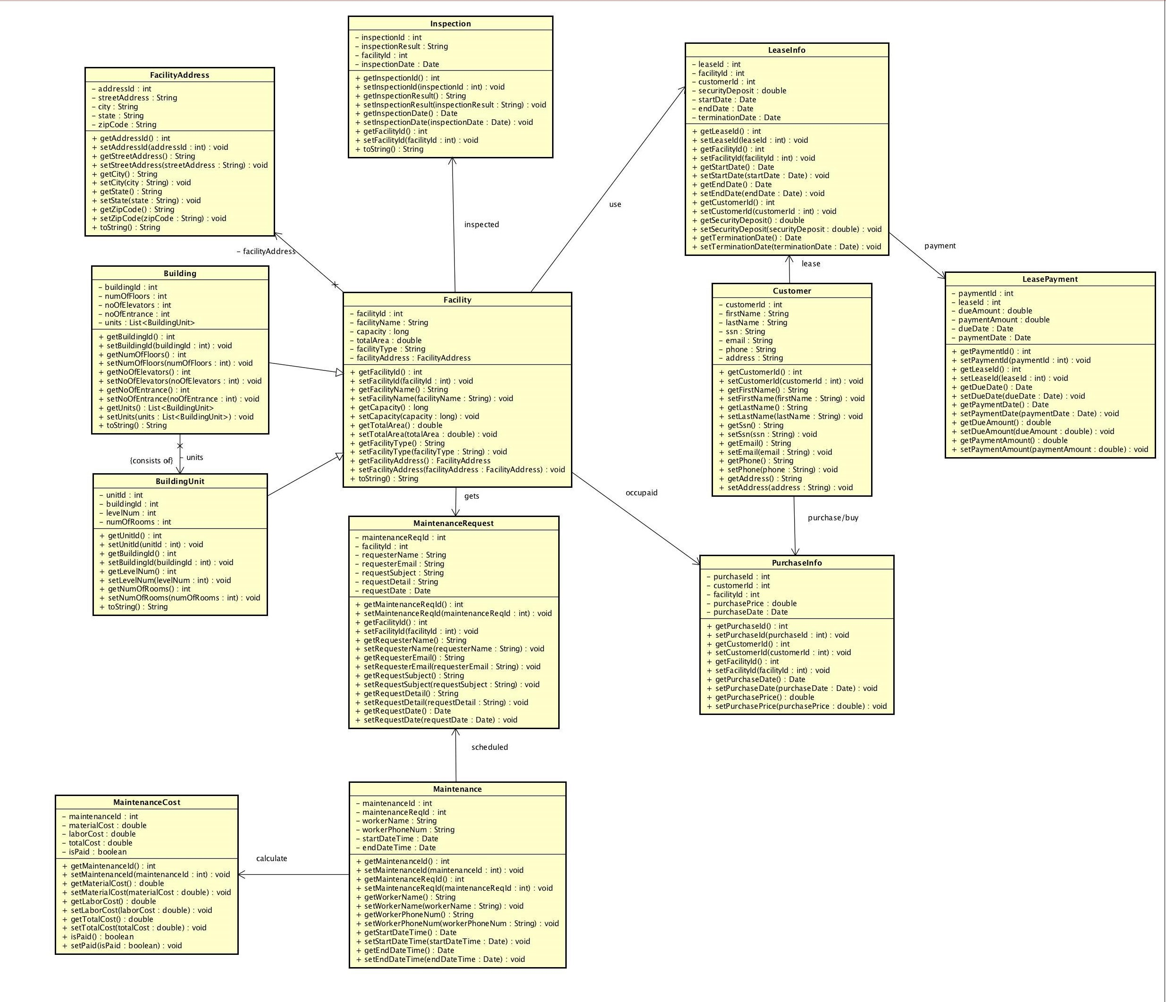

# Database Model

|  |  |  |  |
| --- | --- | --- | --- |
| building |  |  |  |
| building_id |  |  |  |
| facility_id |  |  |  |
| num_of_elevators |  |  |  |
| num_of_floors |  |  |  |
| num_of_entrance |  |  |  |

|  |  |  |  |
| --- | --- | --- | --- |
| building_unit |  |  |  |
| unit_id |  |  |  |
| facility_id |  |  |  |
| level_num |  |  |  |
| num_of_rooms |  |  |  |

|  |  |  |  |
| --- | --- | --- | --- |
| customer |  |  |  |
| customer_id |  |  |  |
| first_name |  |  |  |
| last_name |  |  |  |
| SSN |  |  |  |
| email |  |  |  |
| phone |  |  |  |
| address |  |  |  |

|  |  |  |  |
| --- | --- | --- | --- |
| facility_address |  |  |  |
| facility_address_id |  |  |  |
| street_address |  |  |  |
| city |  |  |  |
| state |  |  |  |
| zip |  |  |  |

|  |  |  |  |
| --- | --- | --- | --- |
| maintenance |  |  |  |
| maintenance _id |  |  |  |
| main_req_id |  |  |  |
| worker_name |  |  |  |
| worker_phone |  |  |  |
| start_date |  |  |  |
| end_date |  |  |  |

|  |  |  |  |
| --- | --- | --- | --- |
| facility |  |  |  |
| facility_id |  |  |  |
| facility_name |  |  |  |
| capacity |  |  |  |
| total_area |  |  |  |
| facility_type |  |  |  |
| facility_address_id |  |  |  |

|  |  |  |  |
| --- | --- | --- | --- |
| inspection |  |  |  |
| inspection _id |  |  |  |
| inspection _date |  |  |  |
| inspection_result |  |  |  |
| facility_id |  |  |  |

|  |  |  |  |
| --- | --- | --- | --- |
| maintenance_cost |  |  |  |
| maintenance _id |  |  |  |
| material_cost |  |  |  |
| labour_cost |  |  |  |
| total_cost |  |  |  |
| is_paid |  |  |  |

|  |  |  |  |
| --- | --- | --- | --- |
| maintenance_request |  |  |  |
| main_req_id |  |  |  |
| facility_id |  |  |  |
| request_date |  |  |  |
| name_of_requester |  |  |  |
| detail |  |  |  |
| email |  |  |  |
| subject |  |  |  |

|  |  |  |  |
| --- | --- | --- | --- |
| purchase_info |  |  |  |
| purchase _id |  |  |  |
| customer_id |  |  |  |
| facility_id |  |  |  |
| purchase_date |  |  |  |
| purchase_price |  |  |  |

|  |  |  |  |
| --- | --- | --- | --- |
| lease_info |  |  |  |
| lease _id |  |  |  |
| facility_id |  |  |  |
| start_date |  |  |  |
| end_date |  |  |  |
| customer_id |  |  |  |
| security_deposite |  |  |  |
| termination_date |  |  |  |
| status |  |  |  |

|  |  |  |  |
| --- | --- | --- | --- |
| lease_payment |  |  |  |
| payment _id |  |  |  |
| lease _id |  |  |  |
| amount_due |  |  |  |
| payment_date |  |  |  |
| amount_paid |  |  |  |
| due_date |  |  |  |

**GitHub Repository:**

<https://github.com/snowreen/facility-management>

**Database:**

MySQL

**How to Run the Project**

Database DDL statements are available inside database.txt (attached with email and also available in Github [https://github.com/snowreen/facility-management](https://github.com/snowreen/facility-management%20)) . You can run it from command line using following command (change path to this file path, mysql server needs to be started before that):

mysql < {path}/database.txt

Please change mysql database username and password according to yours in DBHelper.java class (line 33).

**For Testing,**

FacilityClient.java has the main method to test this application.

We have created all the domain models, interfaces and implementation classes of those interfaces. Also created DAO classes to fetch/insert/update from database. We are still trying to deploy MySQL database to Heroku but not succeed yet. Everything runs fine in our local.